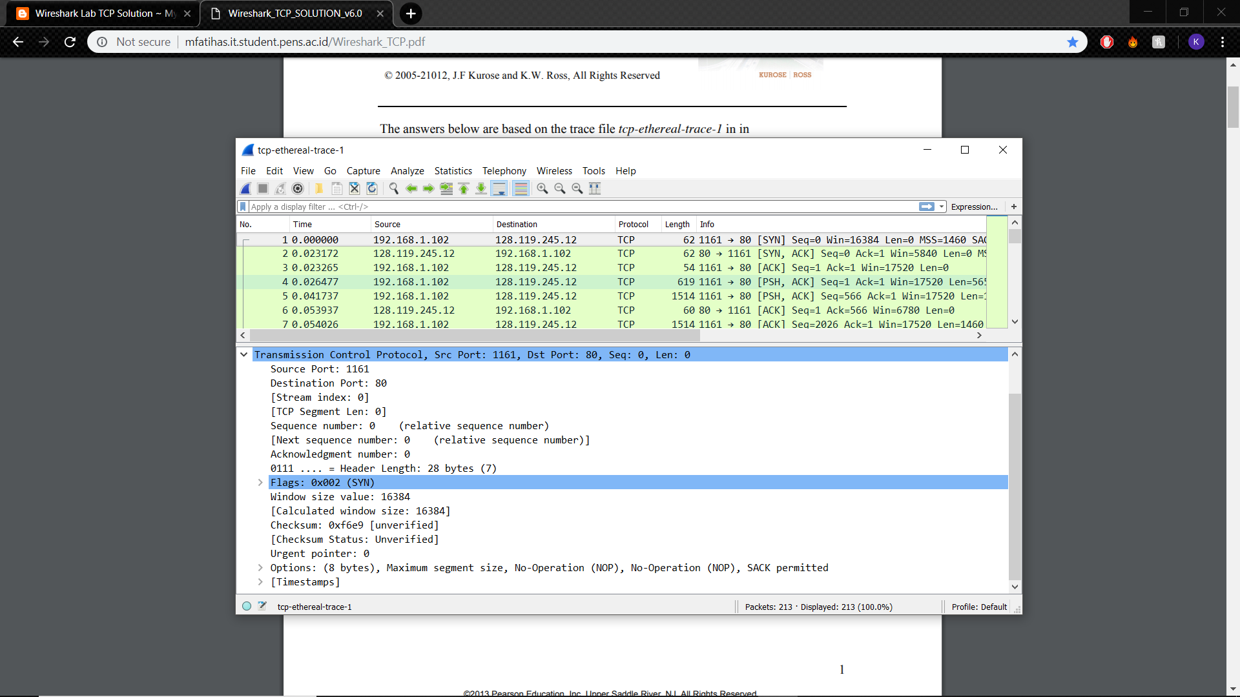**PART 1**

1. IP Address: 192.168.1.102 TCP Port Number: 1161
2. IP Address: 128.119.245.12 TCP Port Number: 80
3. Was unable to create my own trace with “Alice in Wonderland” file.

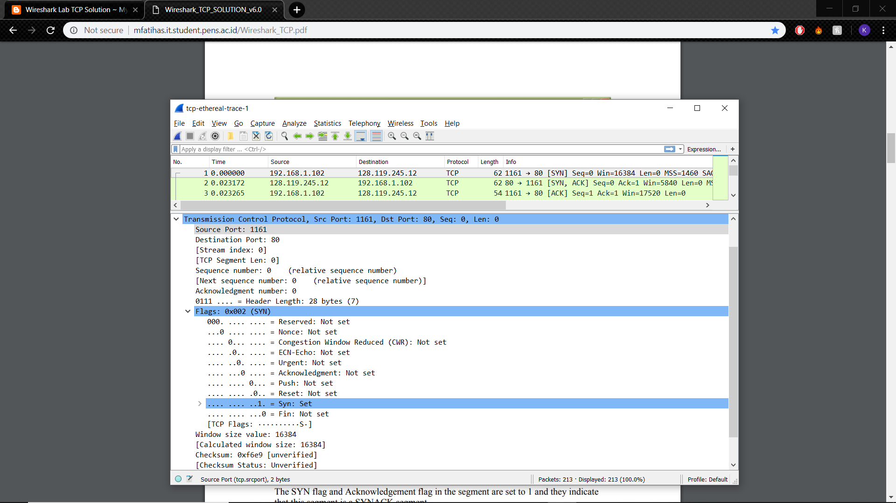

1. The TCP SYN sequence number is 0. The SYN flag indicates that this is a SYN segment (SYN: Set).

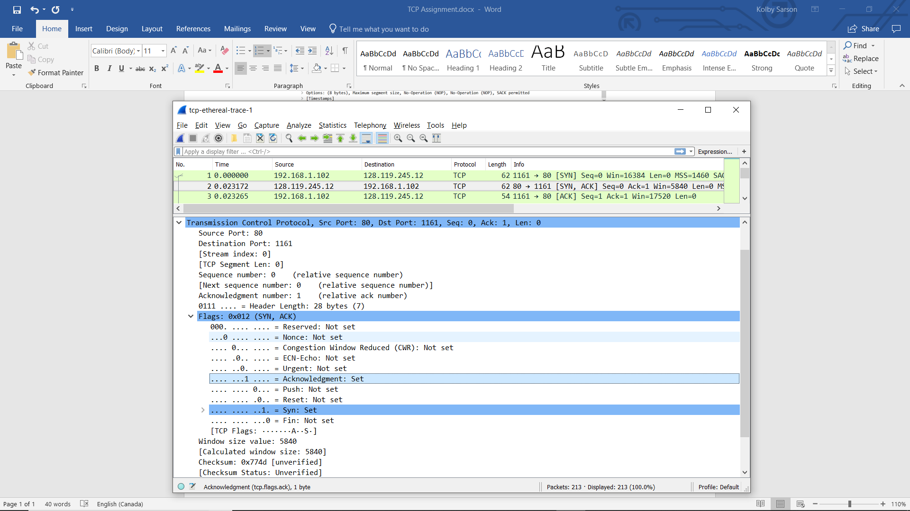

1. The SYNACK sequence number is 0. The Acknowledgment field has a value of 1, which is determined by adding 1 to the sequence number of the SYN segment from the client (0+1=1). The SYN flag and the Acknowledgment flag indicate that this is a SYNACK segment (SYN: Set & Acknowledgment: Set).

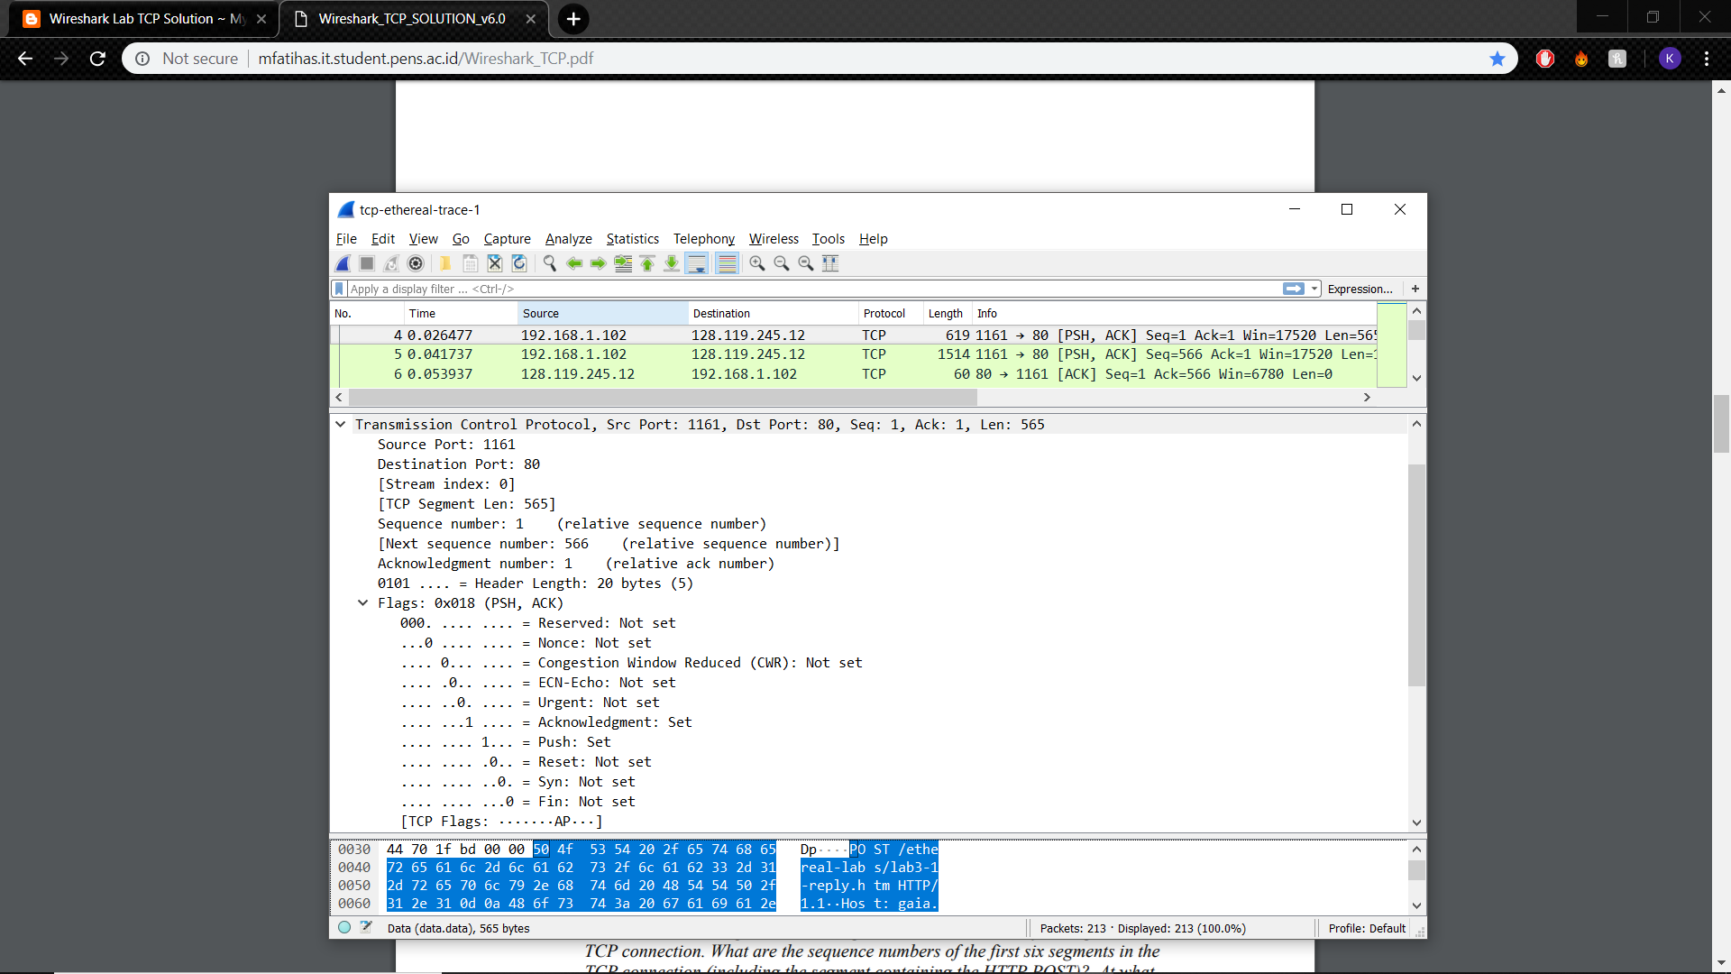

1. The HTTP POST TCP segment has the sequence number 1.

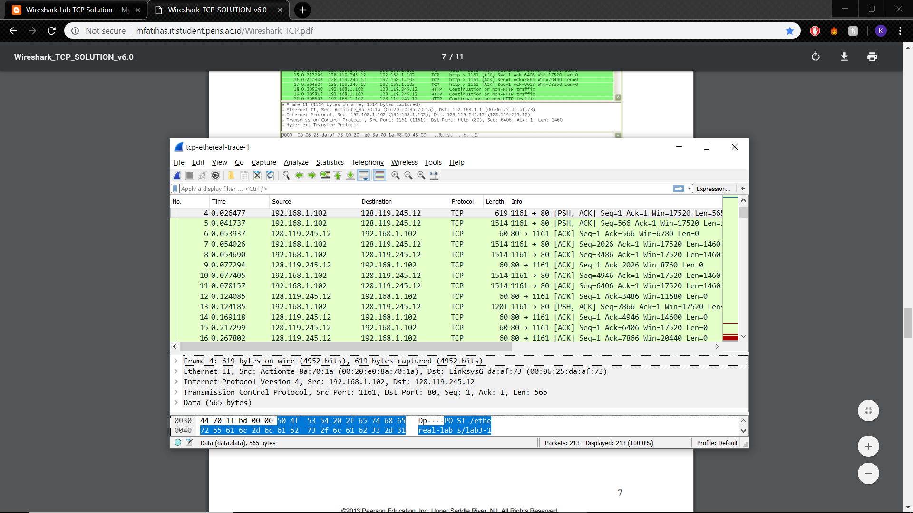



|  |  |  |  |  |  |  |  |
| --- | --- | --- | --- | --- | --- | --- | --- |
| Segment # | Trace # | ACK # | Sequence # | Sent Time | ACK Received Time | RTT (seconds) | Estimated RTT |
| 1 | 4 | 6 | 1 | 0. 026477 | 0. 053937 | 0. 02746 | 0. 02746 |
| 2 | 5 | 9 | 566 | 0. 041737 | 0. 077294 | 0. 035557 | 0.0285 |
| 3 | 7 | 12 | 2026 | 0. 054026 | 0. 124085 | 0. 070059 | 0. 0337 |
| 4 | 8 | 14 | 2486 | 0. 054690 | 0. 169118 | 0. 11443 | 0. 0438 |
| 5 | 10 | 15 | 4946 | 0. 077405 | 0. 217299 | 0. 13989 | 0. 0558 |
| 6 | 11 | 16 | 6406 | 0. 078157 | 0. 267802 | 0. 18964 | 0. 0725 |

**Estimated RTT Calculations**

**Formula:** EstimatedRTT = 0.875 * EstimatedRTT + 0.125 * SampleRTT

**After ACK of Segment 1:**

EstimatedRTT = RTT for Segment 1 = 0.02746

**After ACK of Segment 2:**

EstimatedRTT = 0.875*0.02746+0.125*0.035557 = 0.0240475+0.0044446 = 0.0285

**After ACK of Segment 3:**

EstimatedRTT = 0.875*0.0285+0.125*0.070059 = 0.0249375+0.0087573 = 0.0337

**After ACK of Segment 4:**

EstimatedRTT = 0.875*0.0337+0.125*0.11443 = 0.0294875+0.0143037 = 0.0438

**After ACK of Segment 5:**

EstimatedRTT = 0.875*0.0438+0.125*0.13989 = 0.038325+0.0174862 = 0.0558

**After ACK of Segment 6:**

EstimatedRTT = 0.875*0.0558+0.125*0.18964 = 0.048825+0.023705 = 0.0725

1. The Length of the first TCP segment is 565 bytes and the Lengths of the remaining 5 TCP segments are 1460 bytes.

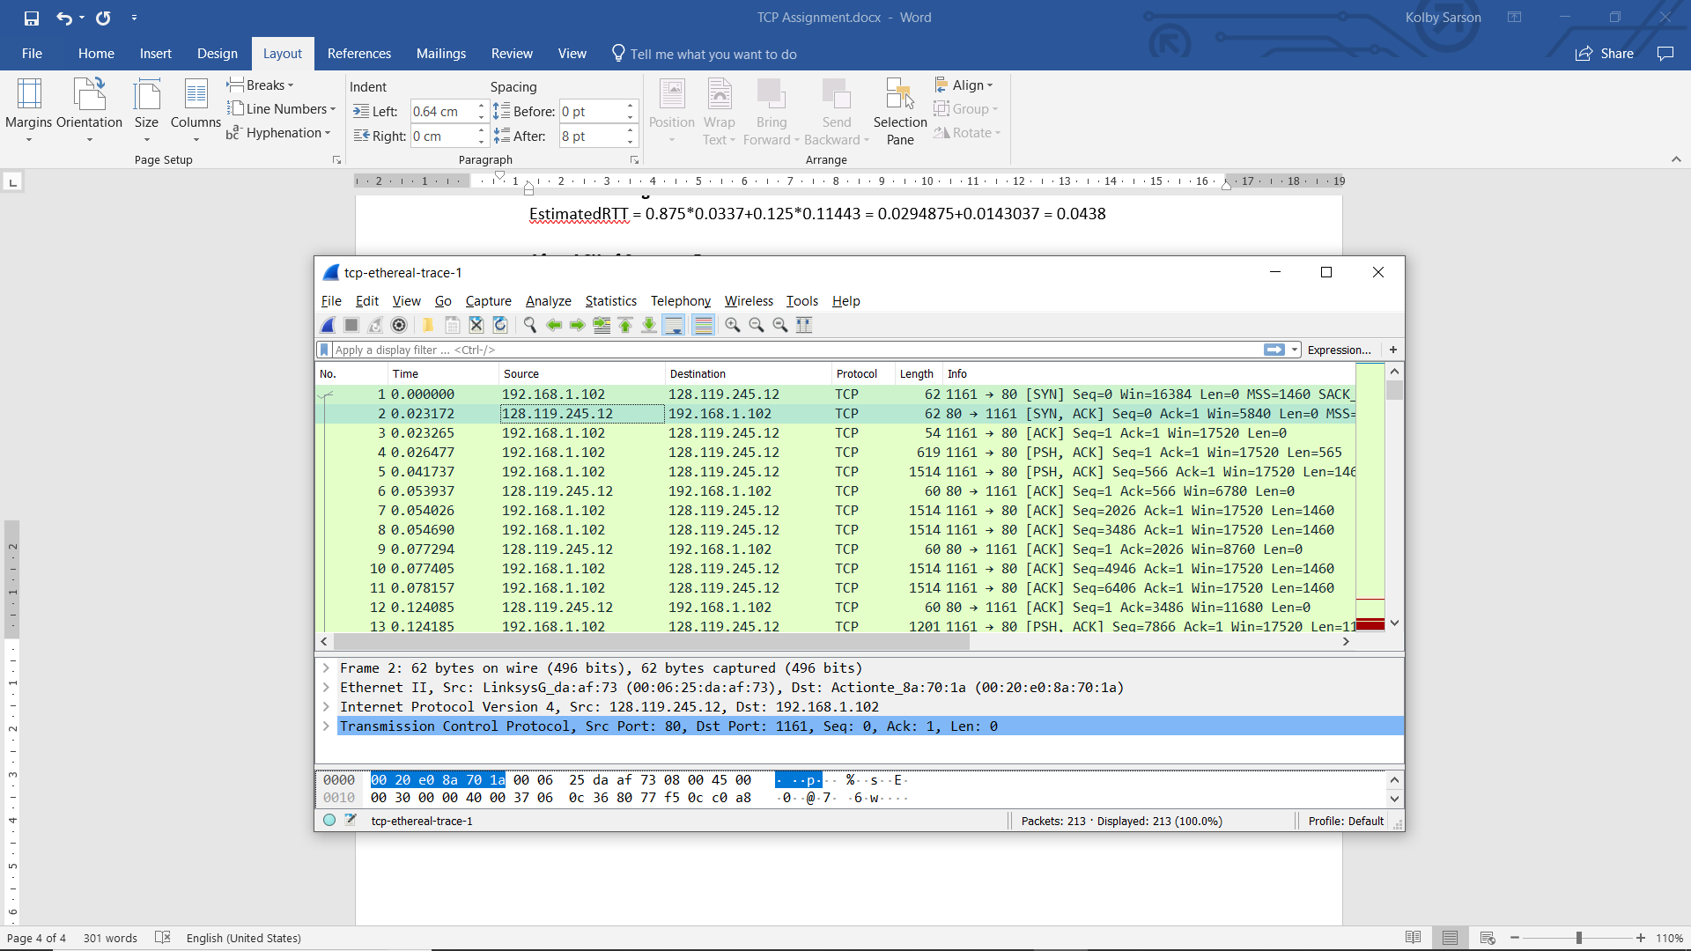

1. The minimum amount of available buffer space advertised at the received for the entire trace is 5840 bytes (Win=5840). The receiver window increases up to a maximum of 62780 (Win=62780). The lack of buffer space never throttles the sender in this trace.

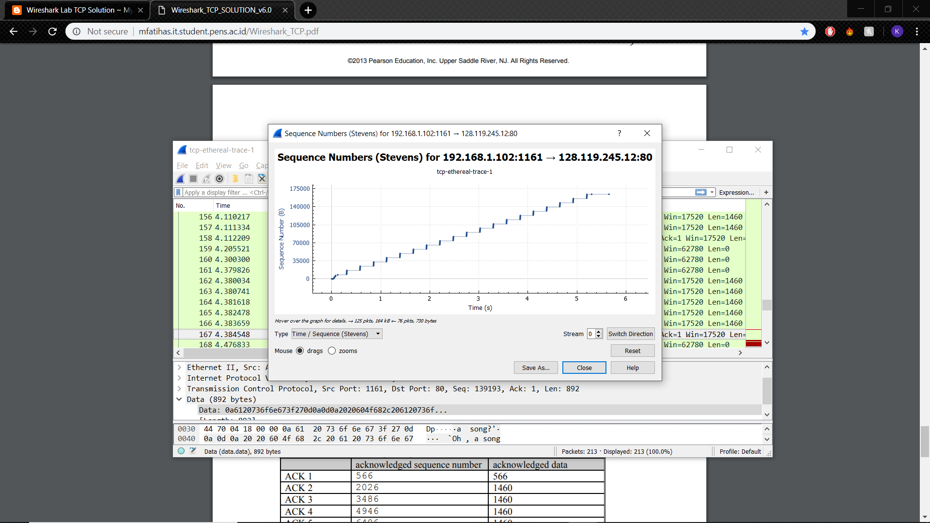

1. There are no retransmitted segments in the trace file. I checked to see that the sequence numbers followed a positive trend, never decreasing, which would indicate a repeated segment.

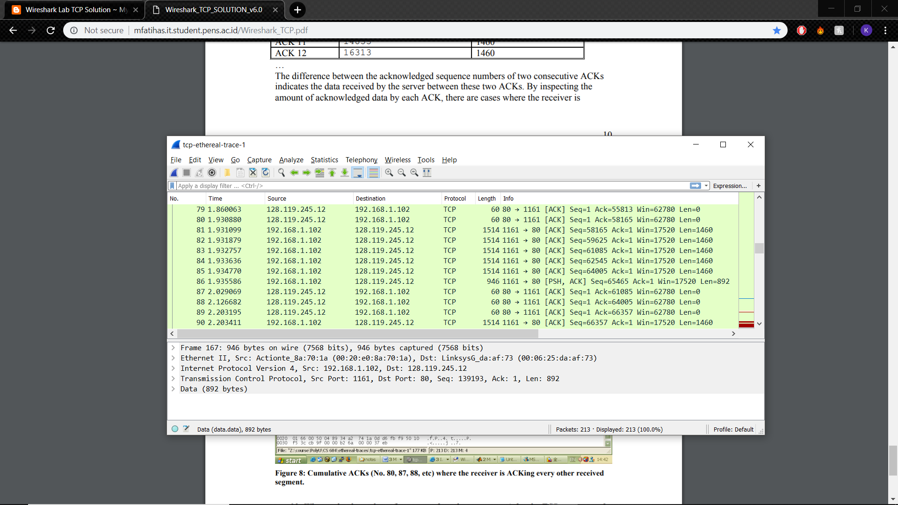

1. The typical amount of data received by acknowledging in an ACK seems to be 1460. One case where the receiver is ACKing every other segment is seen in packets numbered 87 and 88, where the ACK increase is 2920, which is 1460*2.

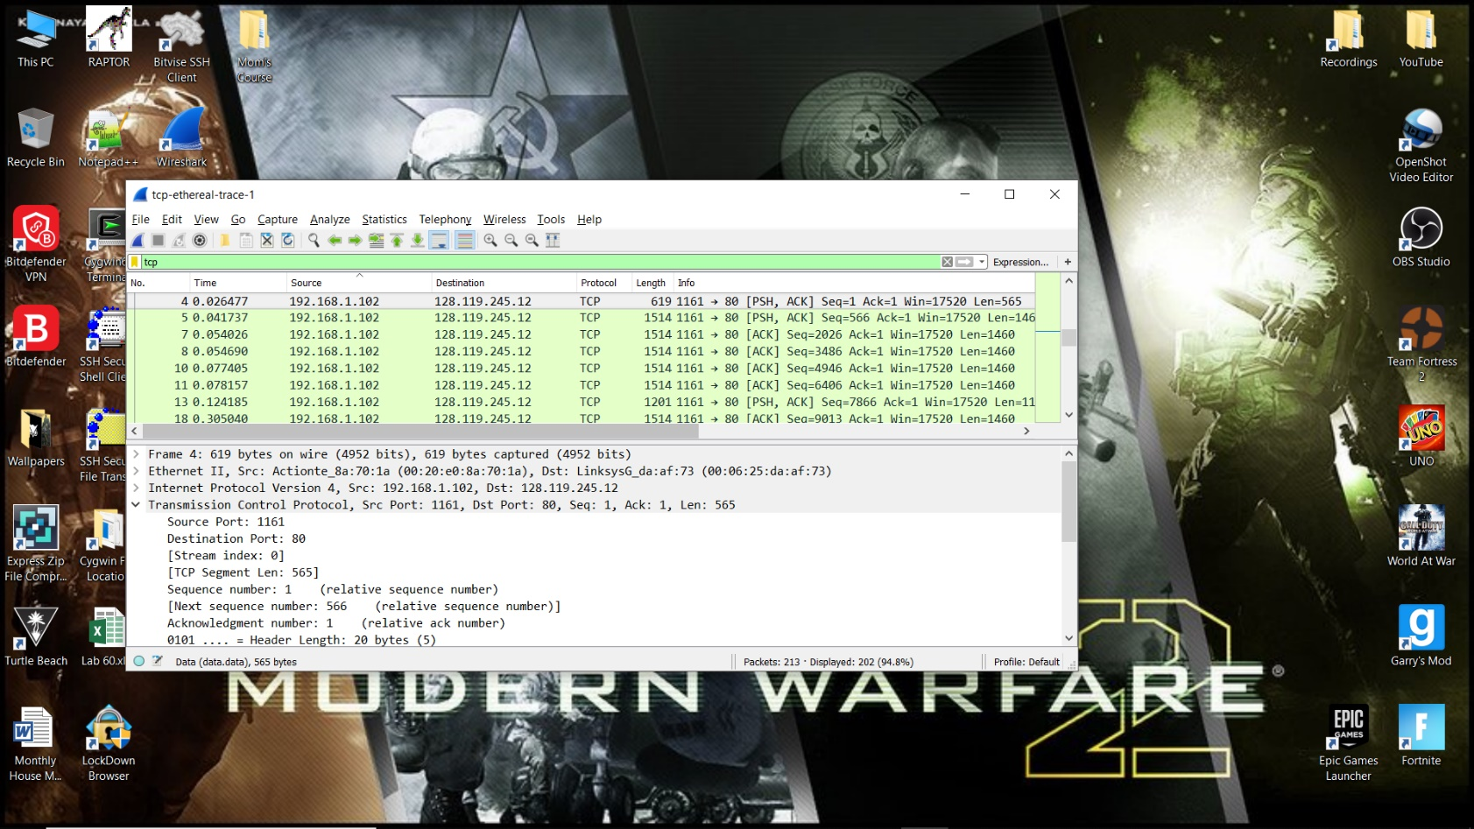

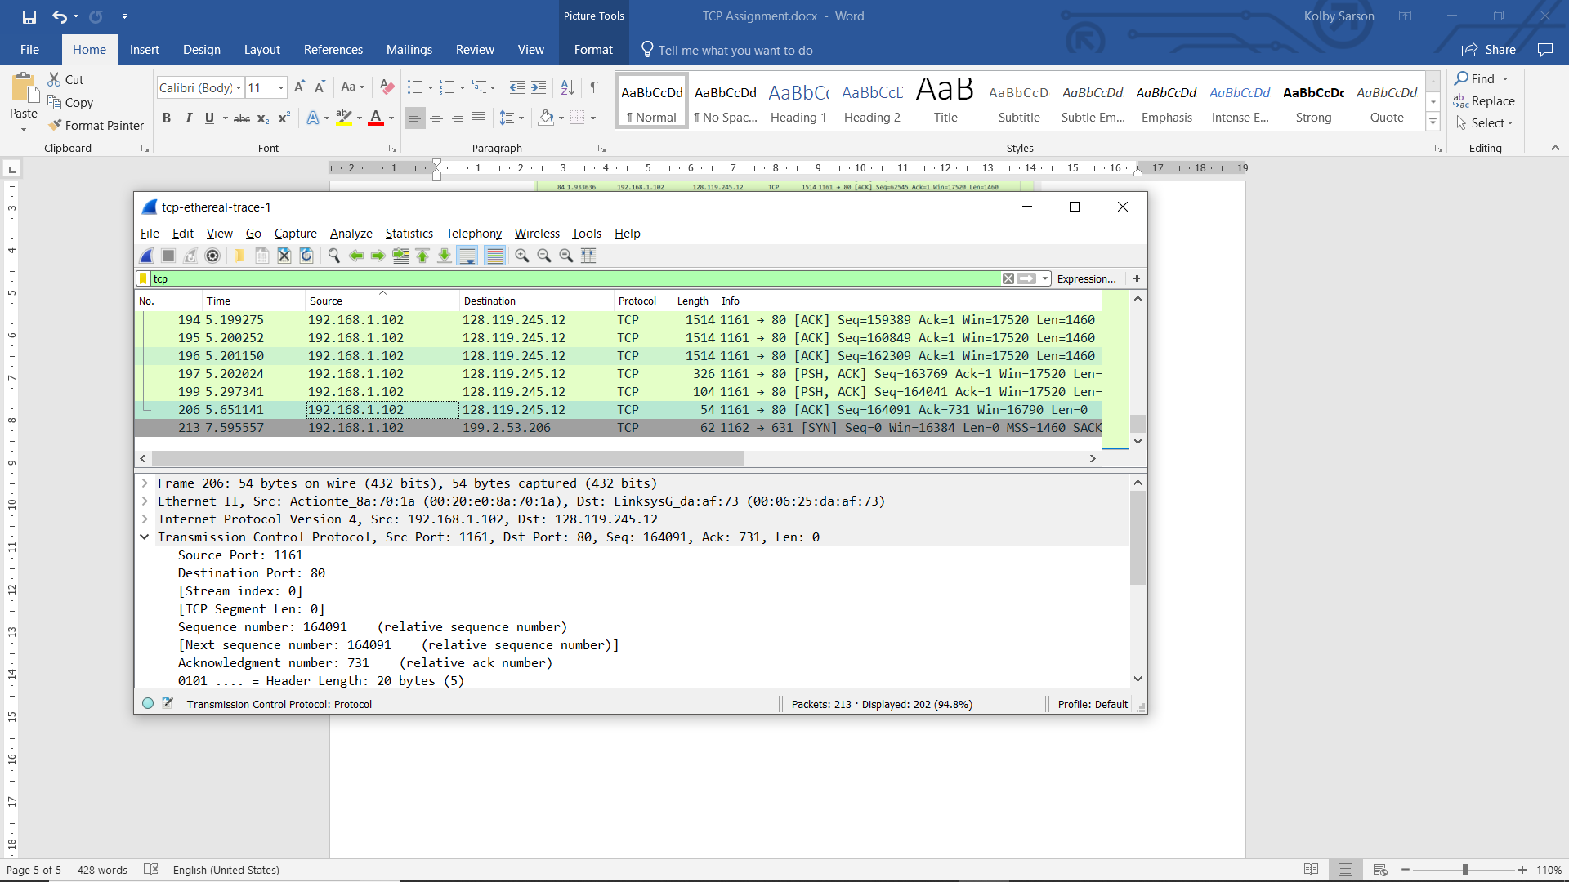

1. Throughput

= (Amount of Data Transmitted) / (Time Incurred)

= ((End Sequence #) – 1) / ((End Time) – (Beginning Time))

= (164091-1) / (5.651141-0.026477)

= 164090 / 5.624664

= 29173 B/s

= 29.173 KB/s

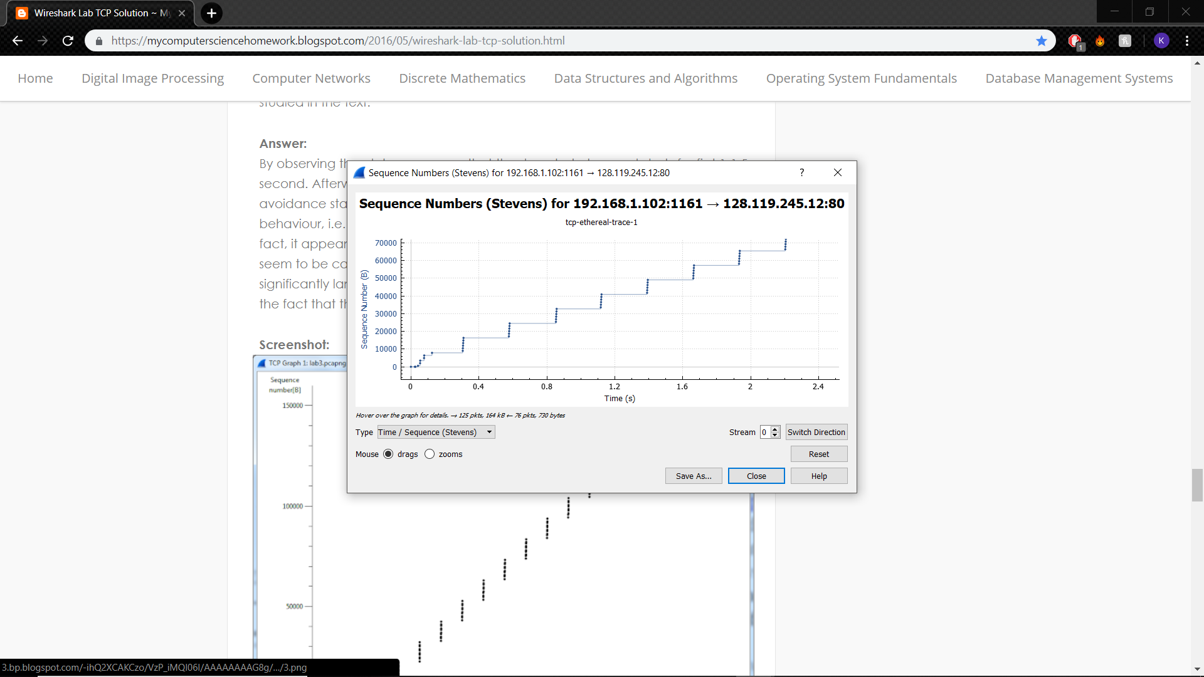

1. 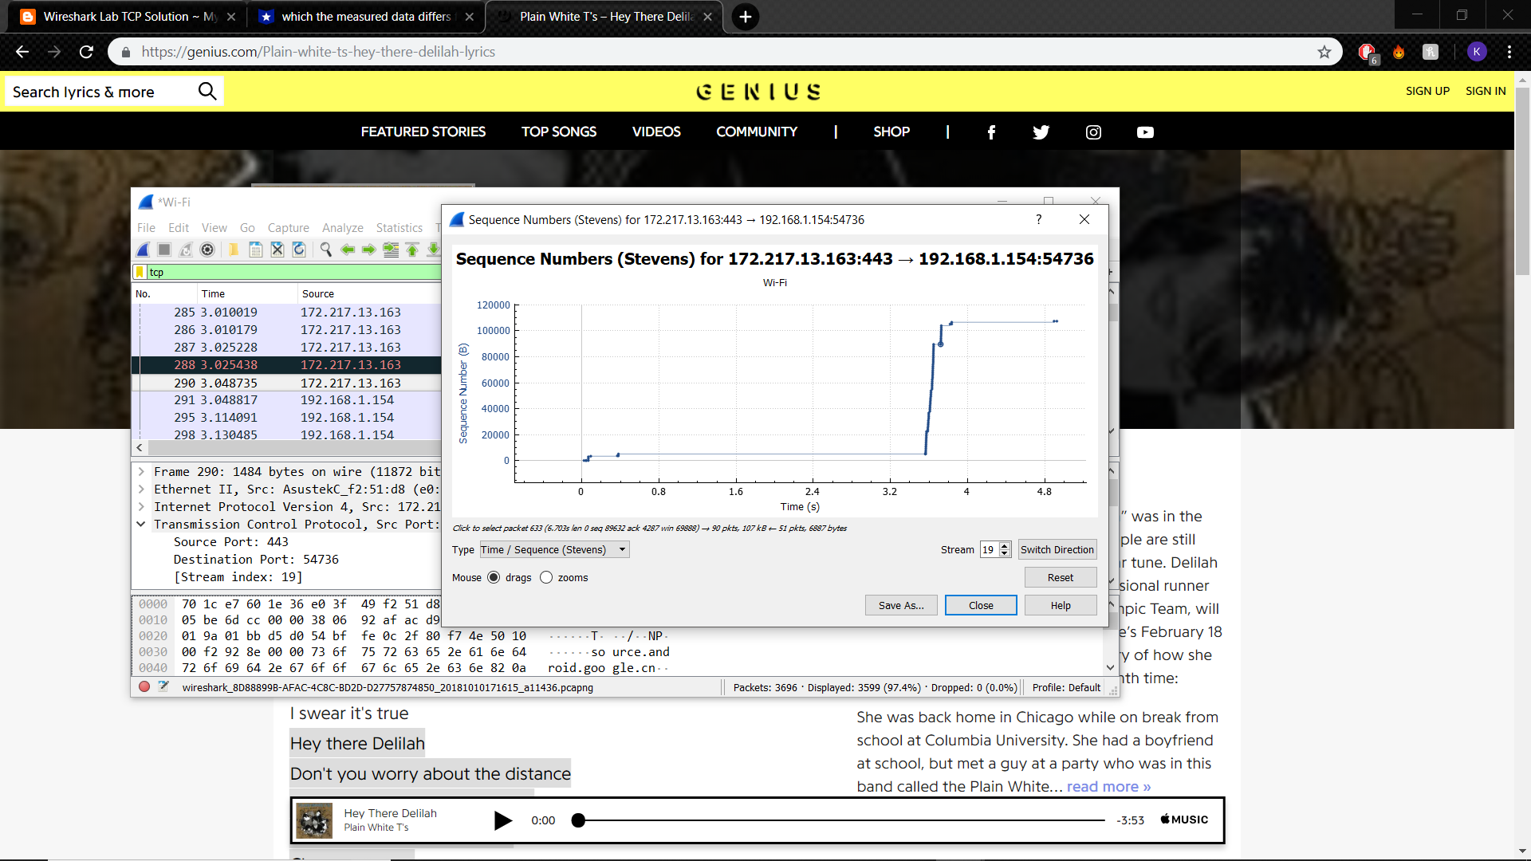It seems that the slow start phase begins at 0 seconds and goes until about 0.15 seconds, after which the TCP session seems to go into a congestion avoidance state. The increase in Sequence Number is not linear, but rather a jagged, where the packets are sent in groups of 6. In the textbook, the graphs for TCP seem to be linear and gradual rather than jagged with quick inclines.
2. The slow start phase begins at 0 seconds and ends at about 0.4 seconds, after which congestion avoidance takes over.